Project Planning
Team ID | Date | Project | Maximum Marks
SWTID-2026-1237 | 30/09/2026 | EduGenie | 5 Marks

Product Backlog,Sprint Schedule and Estimation

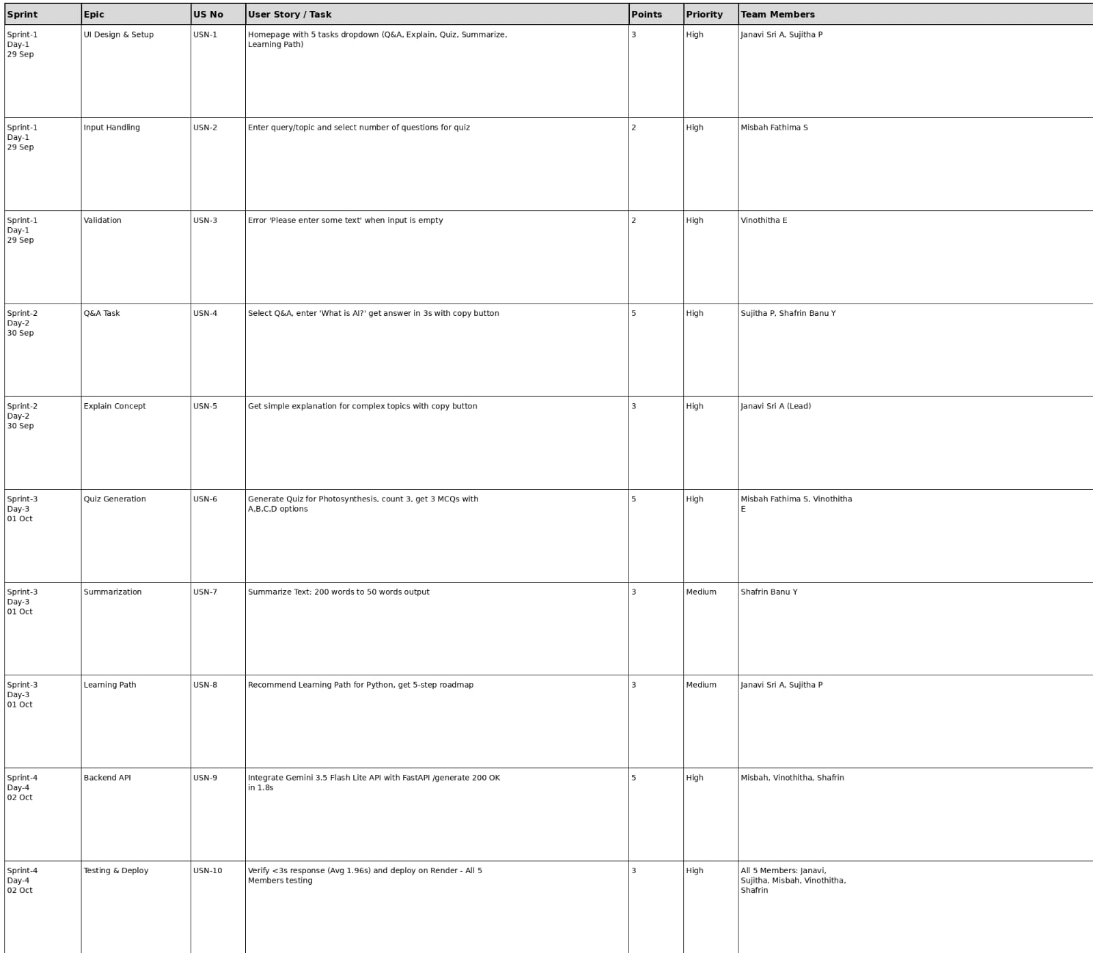

Project Tracker, Velocity & Burndown Chart
